1. 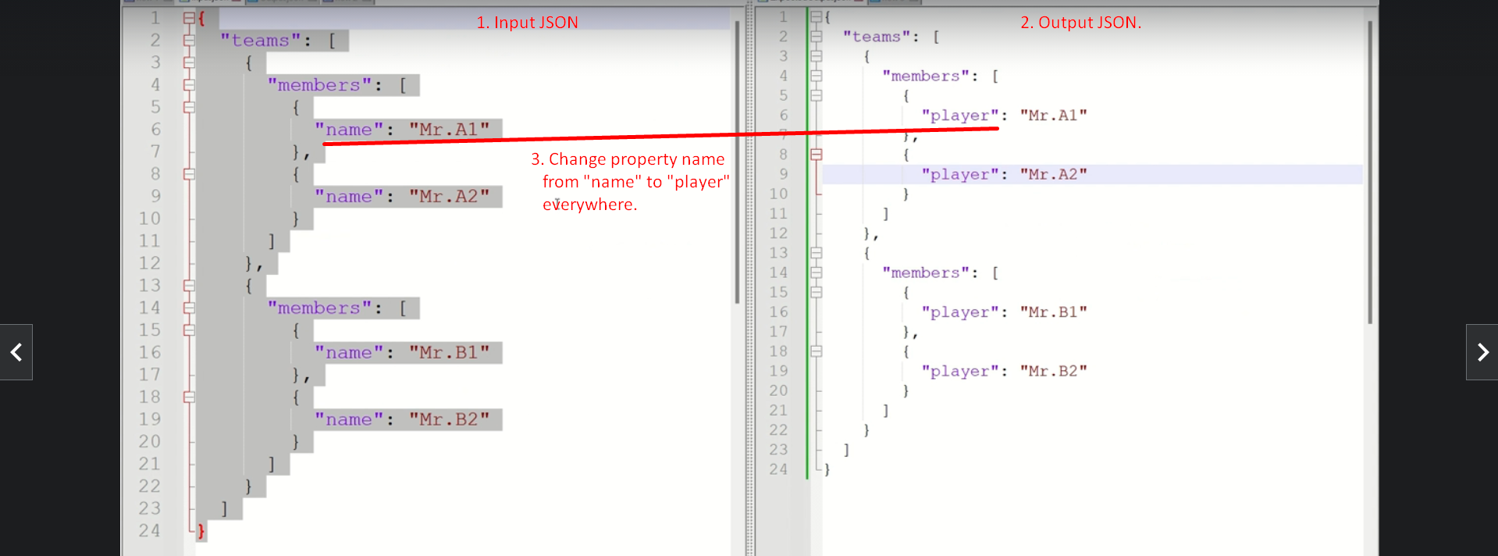
2. We will try many hits to achieve it with fails and success eventually.
3. Always keep in mind before proceeding further that & refers the property in the
4. **Fail Case 01**:  
   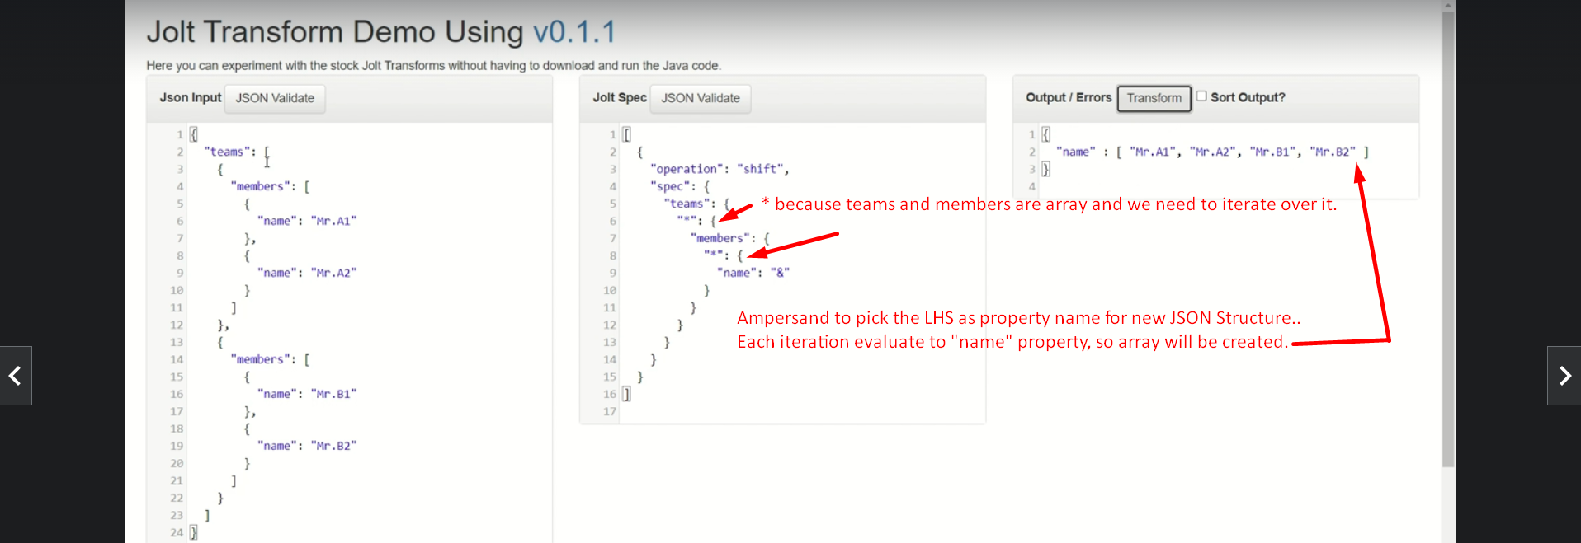
5. **Fail Case 02:**  
   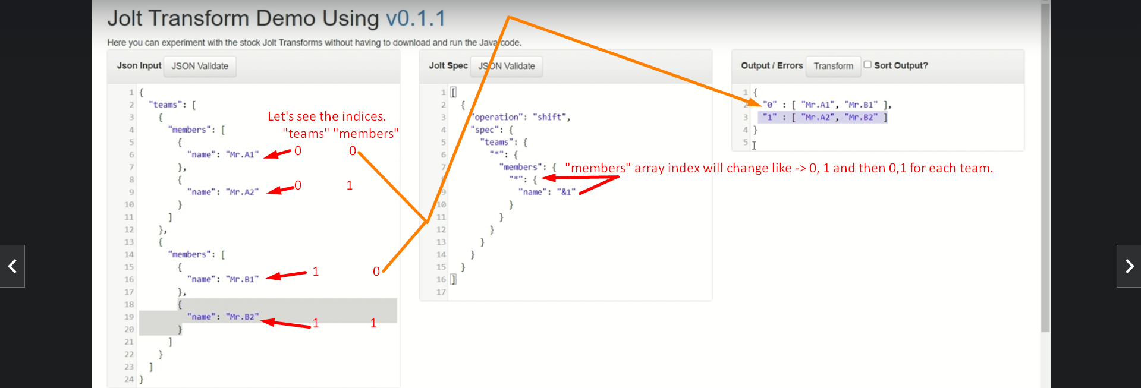
6. **Fail Case 03:**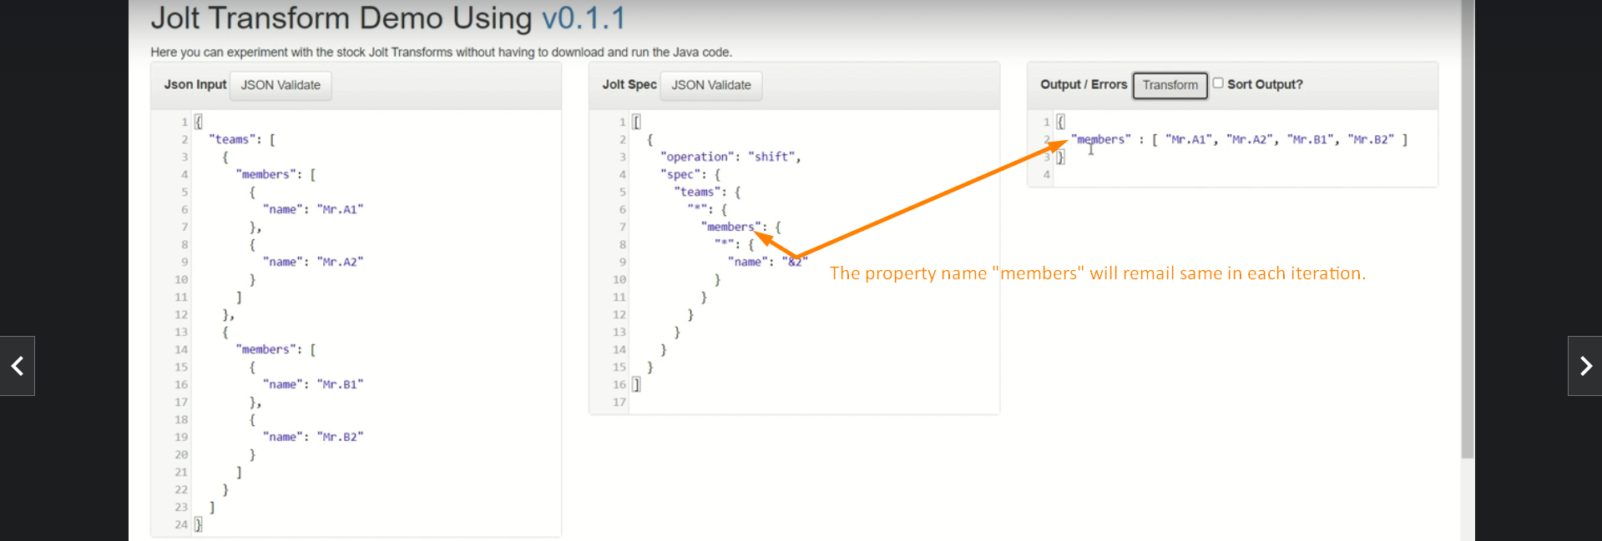
7. **Failed Case 04:**   
   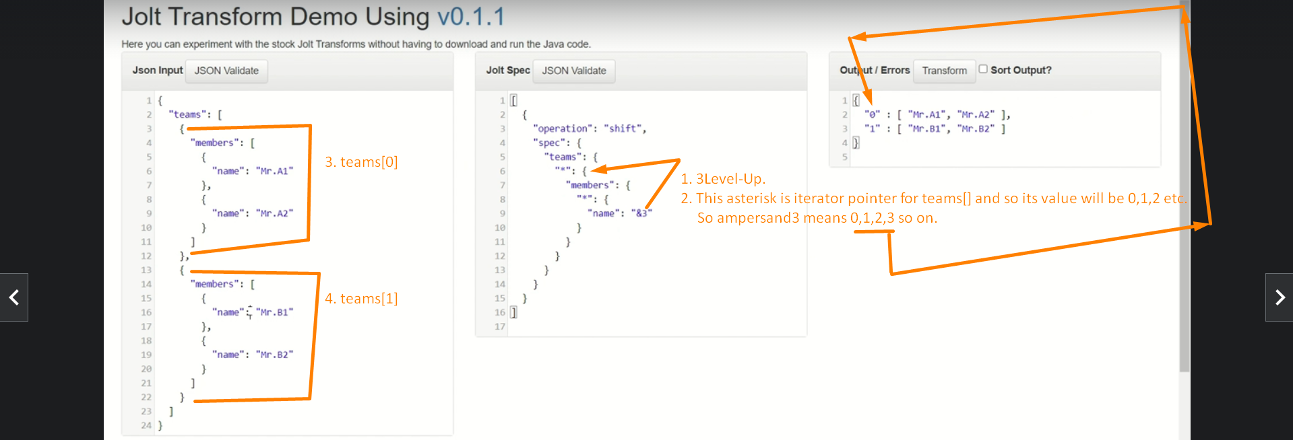
8. **Failed Case 05**:  
   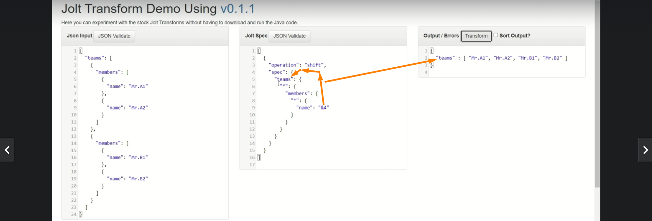
9. **Failed Case 06:**  
   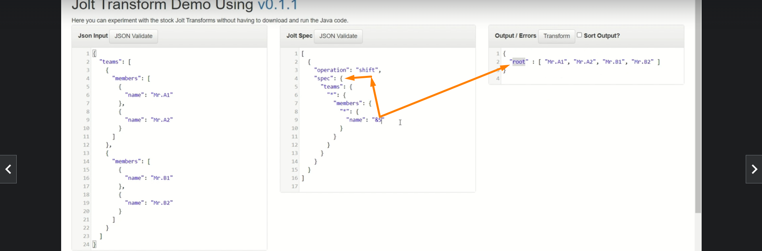
10. **Failed Case 07:**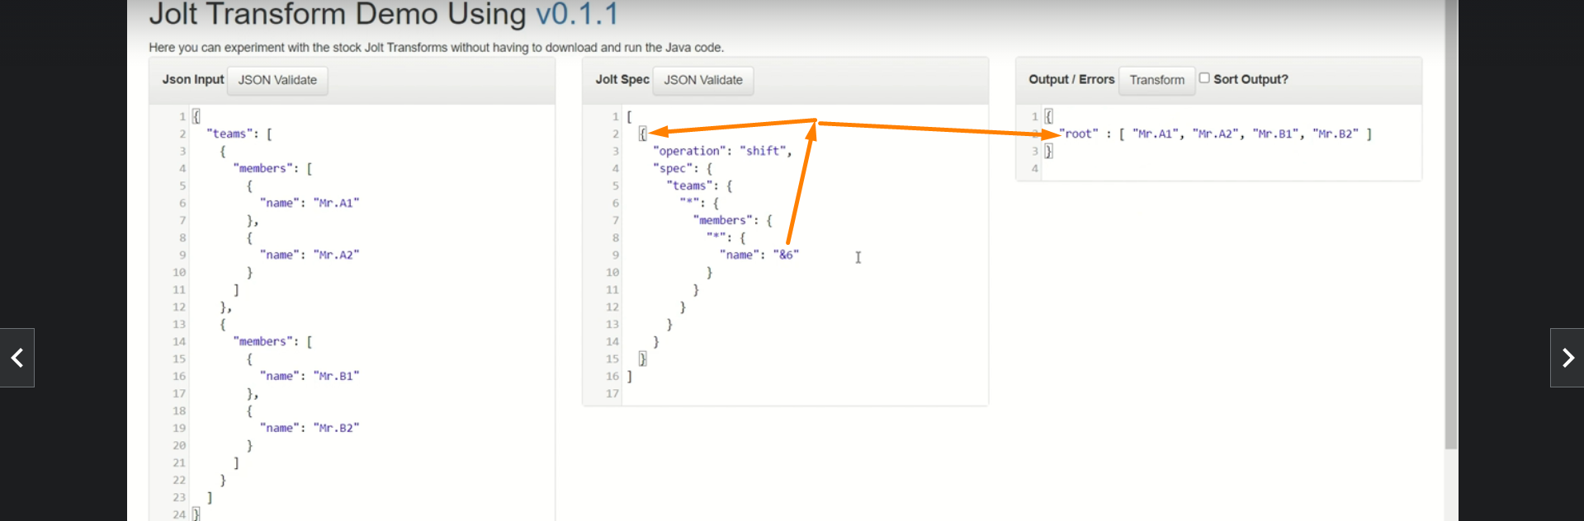
11. **Failed Case 08:**  
    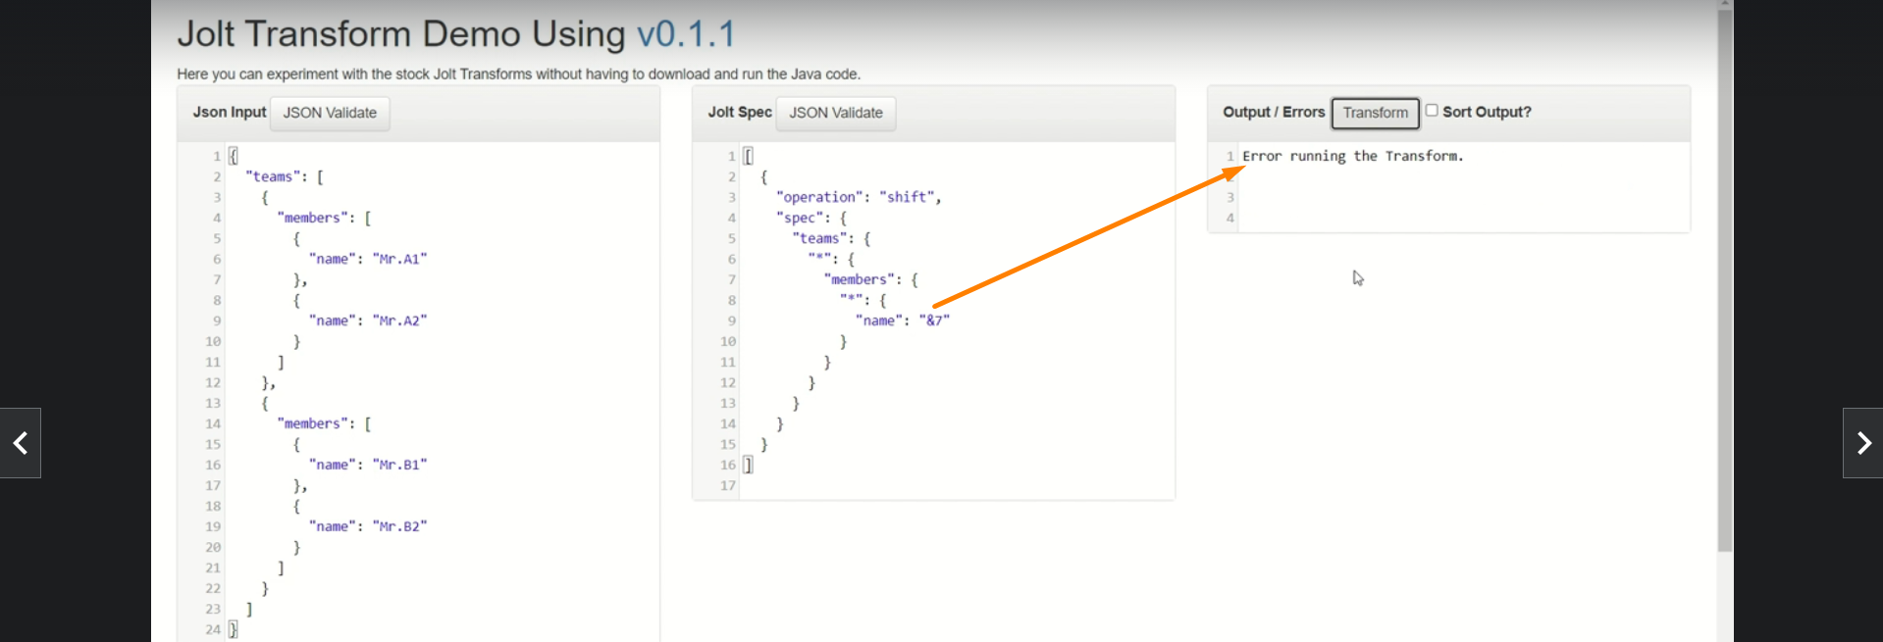
12. **Failed Case:**  
    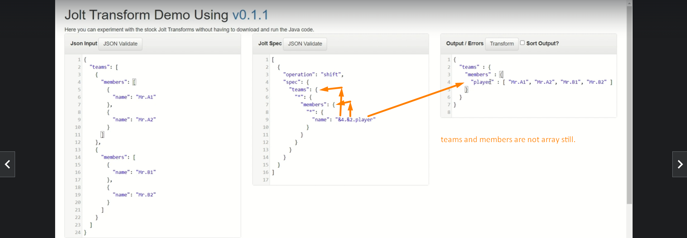
13. **Failed Case:**  
    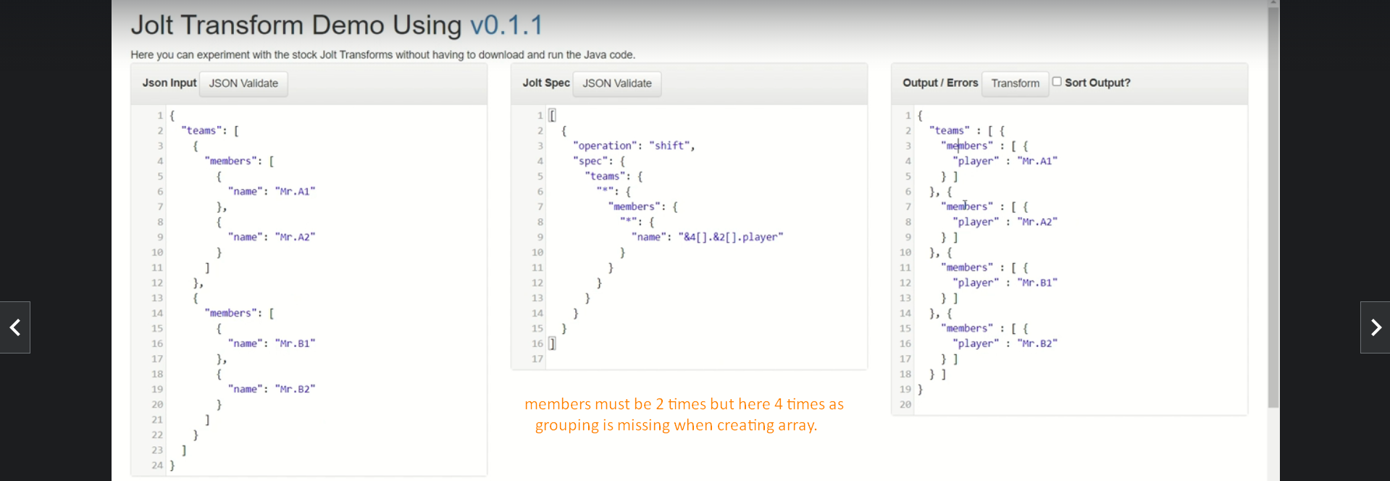
14. **Successful:**  
    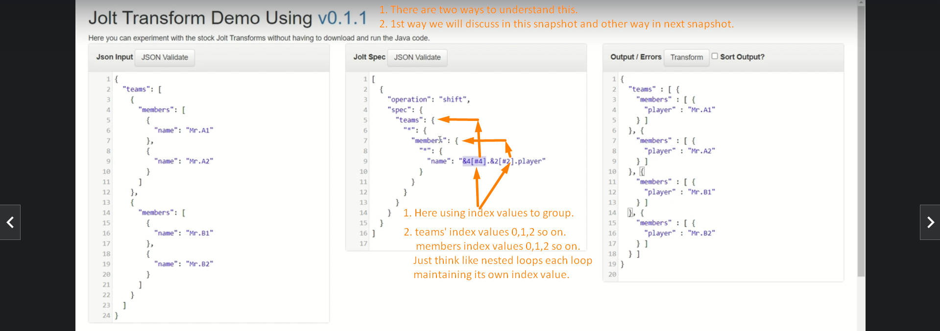 **Successful: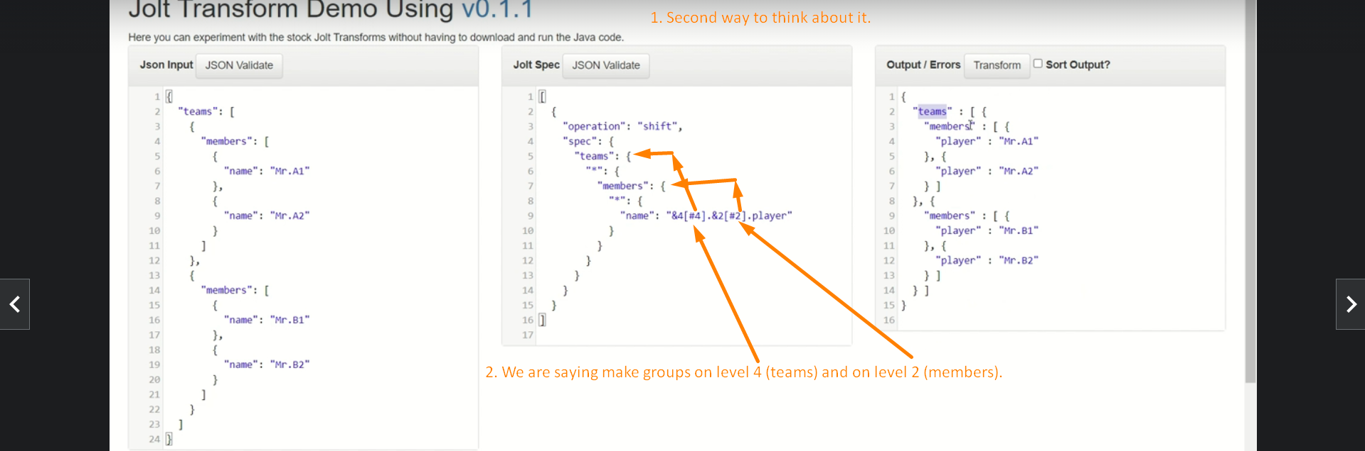 Jatin Success: I did it myself just using the &**